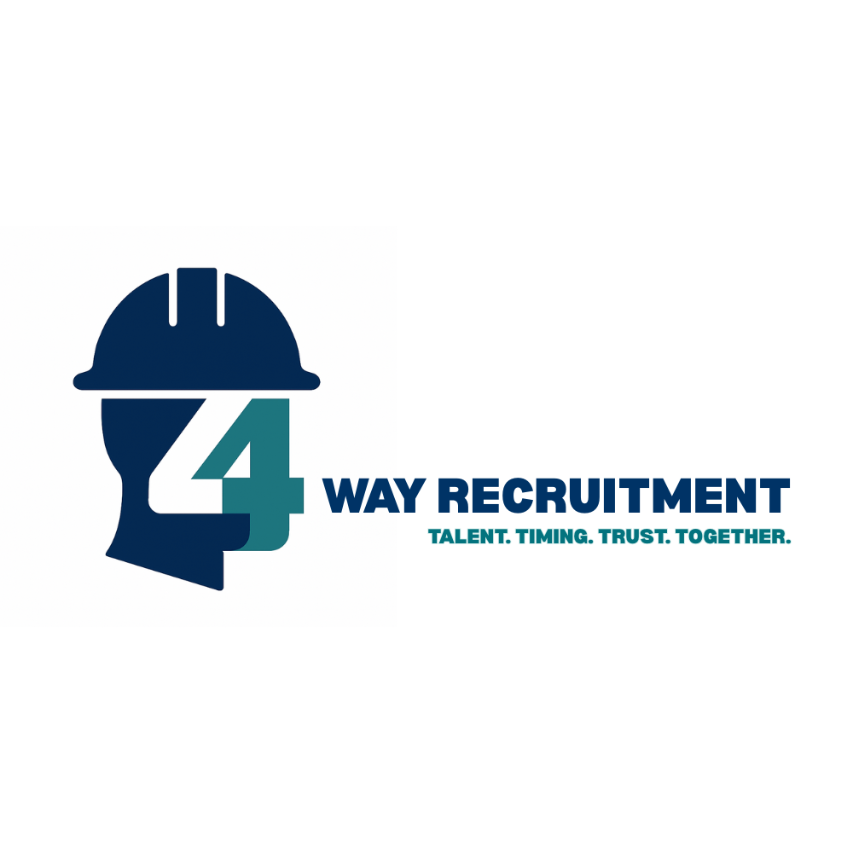
Fire & Security / M&E Industry CV Template

1. Contact Details (Top of Page)
-Full Name
-Location (Town/County)
- Mobile Number
- Email Address
- LinkedIn (optional)
- Driving Licence (Yes/No)
- Van/Vehicle Ownership (if applicable)

2. Personal Profile (Short Paragraph)
A few lines summarising:
- Years of experience
- Core sectors (Fire Alarms, CCTV, Access Control, etc.)
- Key certifications
- What you’re looking for

3. Key Skills / Systems Experience (Bullet List)
Examples:
- Fire: Advanced, Kentec, C-Tec
- Security: Hikvision, Texecom, Paxton
- Electrical: 18th Edition, 2391 Testing & Inspection

4. Certifications & Training
- FIA Units (Design, Install, Maintenance)
- ECS / CSCS / PASMA / IPAF
- 18th Edition / 2391 / NVQ Level 3
- Manufacturer Training
5. Employment History
Reverse chronological order: (most recent first)
- Job Title – Company – Dates
- Key duties
- Systems worked on
- Type of sites (domestic, commercial)
- Achievements
6. Education
- School / College name
- Qualifications
- Dates

7. References
Available on request

